North Carolina Assemblies of God

Junior Bible Quiz

X-League Officiating Guide

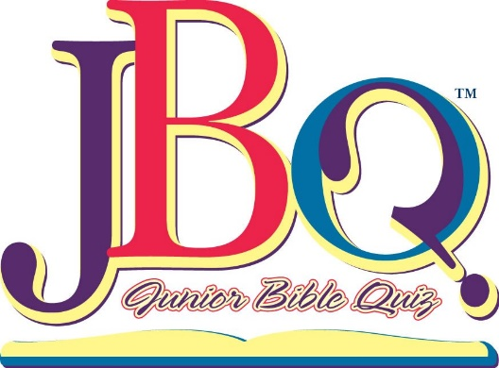 2018 – 2019 Season

What is X-League?

X-League quizzing is designed to help Kindergarten through 2nd grade students learn Bible facts, scriptures, and doctrine. This league is used as a preparation tool for students to move into the Novice and Experience league quizzing. X-league allows children to meet new friends from other churches in their division. It teaches children how to participate in a simple, competitive way. (Please see other manual for information on registering your X-League team.) X-League teams are not restricted to specific rosters during league play. Therefore, no league awards will be given. Ribbons will still be awarded every meet.

Purpose of X-League Manual

The purpose of this manual is to maintain the consistency and equality to how the national guidelines are applied in an X-League match in the state of NC. There has been a lot of discussion as to what is allowed, what should be allowed, and what will be allowed. This manual is an outcome of leadership discussions on how to better serve our X-leaguers.

The X-League Season

Currently, our X-league teams meet during our regular season matches. X-league teams do not compete at Semi-Finals for spots at Districts. X-league does not participate in State Finals. Beginning this year, the February meet will serve as a districts-style meet for X-League teams. Awards will be given as such for the X-League at that time. While this is not a big change, it does eliminate the March meet for both the East and West teams.

The X-League Match

Each X-League match will be governed by the National JBQ Guidelines, just as all other JBQ matches. There will be twenty (20) 10-pt questions asked during the regular match. If the match requires overtime, then 3 10-pt questions will be asked. If the match is still tied at the end of the overtime portion of the match, sudden death will go into effect. Sudden death consists of 10 pointers being continuously asked until someone gets one right or wrong. ALL OTHER GUIDELINES APPLY.

Officiating in X-League

Officials are extremely important in the running of a Junior Bible Quiz match. They oversee the matches to make sure the guidelines are followed and keep things running smoothly. ALL officials must be trained. JBQ church leaders are responsible for training and qualifying officials not present at officials training. Teams only need one official (QM or SK) to get bonus points. Please refer to the Official Guidelines or to the Leaders/Coaches Manual for in-depth information on officials and officiating. Church leaders will need to notify the district or division leaders 10 days prior to the next meet for any officials that are trained after the meet in October. ALL officials must be trained in ALL areas.

We cannot over-emphasize the importance of good and impartial officials. In order to become a good official, individuals must be willing to read and know the rules of JBQ. It is often helpful for them to attend/assist with practices whenever possible; this helps the officials become better acquainted with their tasks and helps the quizzers get used to “playing by the rules” so they aren’t surprised or taken aback by anything that happens at a regular meet. The more closely you run your practice matches to a regular “official” match, the better prepared your quizzers will be. It’s also important to remember, we are teaching the children as much by our attitudes as we are by our knowledge of the rules of JBQ—we’re there to glorify God and have fun with the kids.

Each team is responsible for training and bringing 1 qualified official to each meet. Bonus points for each match the official is present will be awarded as follows:

0 officials = 0 bonus points per match
1 official = 10 bonus points per match

Extra officials are appreciated, but will not result in more than 10 points per match. (Exception to this rule: each church that is represented at one of the district-sponsored officials’ training will receive 5 extra bonus points for the October and November meets.) Teams only receive points for matches for which the officials are present.
JUDGING THE CORRECTNESS OF ANSWERS

Rules for JBQ are less strictly enforced for X- League quizzers due to their young age and lack of experience. However, this is the time to teach the rules to the quizzers where the stress of winning is not in play.

Here is a basic outline of how X-League should be carried out:

- Lots and lots of grace and mercy.
- No fouls (unless verbal correction doesn’t work)
- The quizmaster will be allowed to point to the quizzer who is supposed to answer. This will help them make sure that they know they are supposed to answer.
- The quizmaster is allowed to ask the quizzer to repeat what they said if they are talking too softly.
- The quizmaster will have the discretion to void a question and re-read for both sides if there is too much confusion on an answer (i.e. more than one kid answers, someone begins to talk or help, or just general confusion).
- Repeated words are OK on quotation question answers but not wrong words. I would only allow this in the first meet.
- Automatic official time out if tears appear at the table.
- If a question is interrupted, and the quizzer gives the correct answer without finishing the question, then the QM should give an opportunity for that quizzer to finish the question. If they cannot go back and state the question, then the quizzer should be ruled incorrect. Note: This should only be occurring in the November meet as most X-league quizzers have never been in a match before. However, this should NOT occur in the January and February meets.
- In working with quizzers on interruptions, it is the coach’s job to teach the point of interruption. If a child interrupts too soon, and gives the wrong question. The quizzer is to be counted wrong. (For example, if a quizzer buzzes in on one of the Ten Commandment questions and gets the wrong one. You can NOT count them correct if they eventually say the right one. It must be counted incorrect and reread for the opposing team.)
- Quizzers quiz out when they have six correct answers as outlined. They quiz out backwards when they answer three incorrectly.

